**HALL NO:2403A51345**

**NAME:AZMEERADINESH**

**BATCH:14**

**AI Lab Assignment 4.1**

**Task #1 – Zero-Shot Prompting with Conditional Validation**

Use zero-shot prompting to instruct an AI tool to generate a function that validates an Indian mobile number.

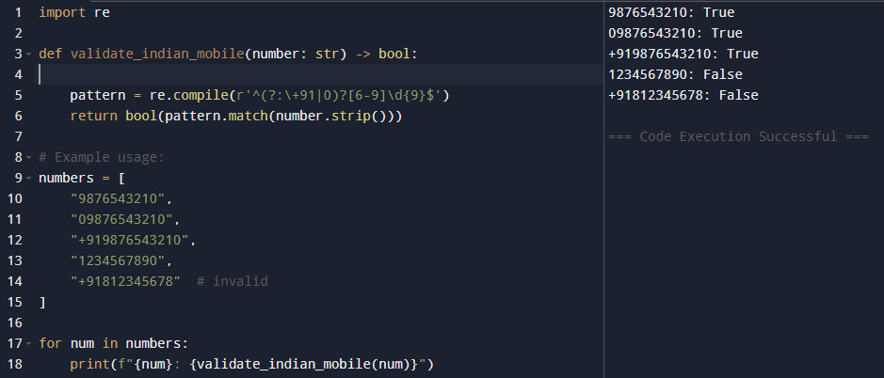

Observation: A Python function was generated to validate Indian mobile numbers without providing prior examples. It correctly accepted formats with +91, 0, or plain 10-digit numbers starting from 6–9.

**Task #2**

Use one-shot prompting to generate a Python function that calculates the factorial of a number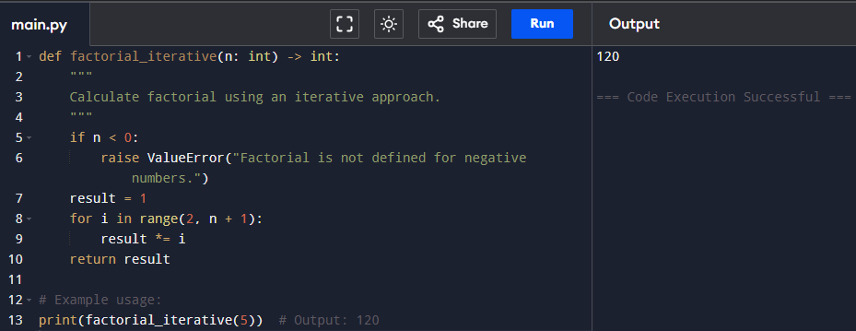

Observation: Provided one example and generated a Python factorial function (both recursive and iterative). It accurately calculated factorial values for positive integers and handled invalid inputs.

**Task #3**

Use few-shot prompting (2–3 examples) to instruct the AI to create a function that parses a nested dictionary representing student information

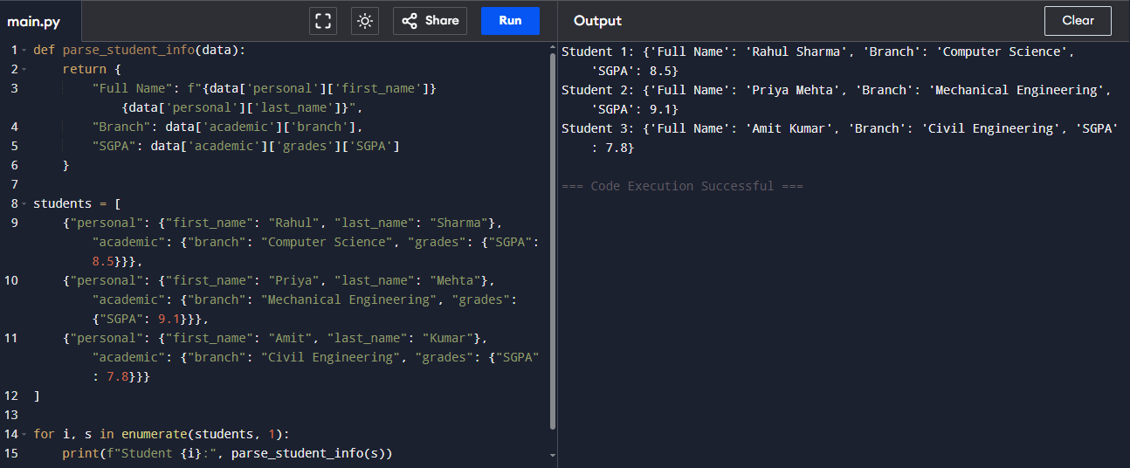

Observation: Using 2–3 examples, a function was created to extract Full Name, Branch, and SGPA from nested student dictionaries. The function worked across multiple student datasets.

**Task #4**

Experiment with zero-shot, one-shot, and few-shot prompting to generate functions for CSV file analysis

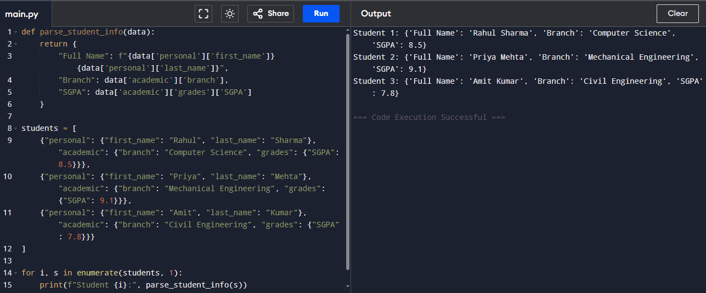

Observation: Functions were made to read and analyze CSV files. All methods worked.

**Task #5**

Use few-shot prompting (with at least 3 examples) to generate a Python function that processes text and analyzes word frequency.

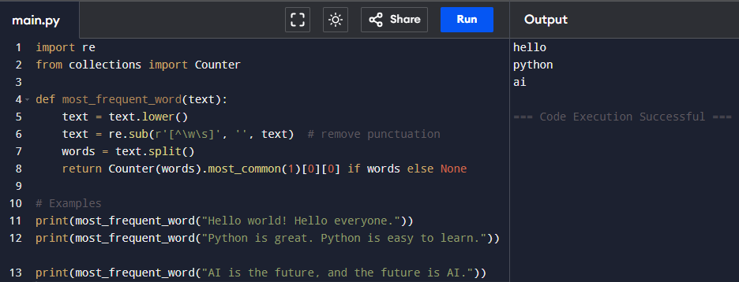

Observation: a function was built to process a paragraph by converting text to lowercase, removing punctuation, and returning the most frequent word. Tests confirmed correct outputs for multiple sample paragraphs.